Bruno, Demore, McFadden

ECE332 – T6A

Pre-Lab 16d

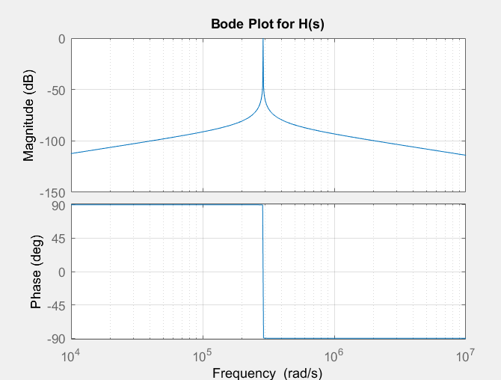

Figure 1: MatLab Bode Plot for Broadband Filter

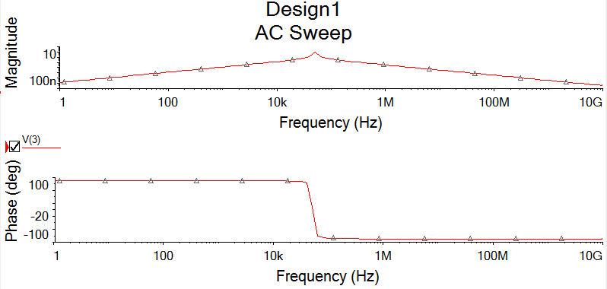

Figure 2: MultiSim Bode Plot for Broadband Filter

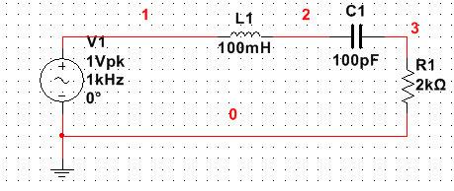

Figure 3: MultiSim Schematic for Broadband Filter

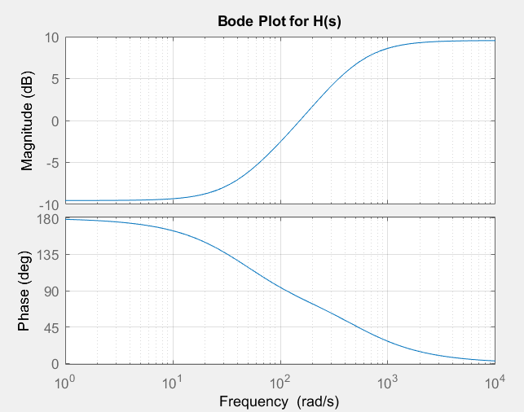

Figure 4: MatLab Bode Plot for High-Q Filter